County Councillor Update  Coker Division SCC  Cllr Mark Keating  August 2021 |  | 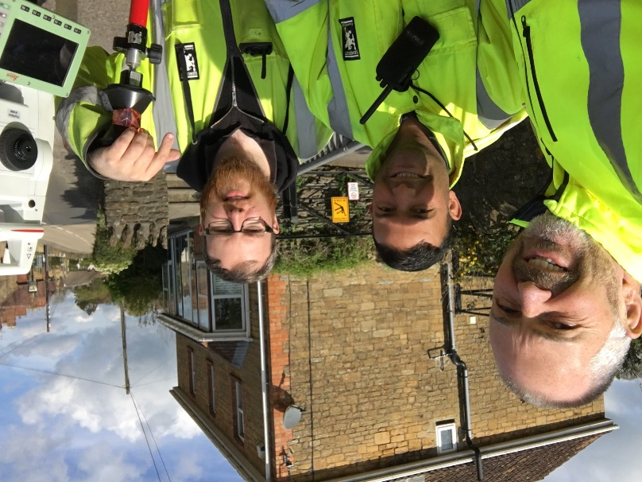
Representing you in - Barwick, Chiselborough, Closworth, East Chinnock, East Coker, Hardington Manderville, Hardington Marsh, Hardington Moor, Haselbury Plucknett, Middle Chinnock, Montacute, North Coker, North Perrott, Norton Sub Hamdon, ​Odcombe, Pendomer, Sutton Bingham, Stoford, West Chinnock, West Coker.
Useful Contacts Resources and Websites: Somerset Coronavirus Support Helpline: 0300 7906275
Cllr Mark Keating – Somerset County Council | E: MAKeating@Somerset.gov.uk | M: 07767 203968
South Somerset Area Highways Office | E: countyroads-southsom@somerset.gov.uk | T: 0300 123 2224
Report Pothole/Road Defect | E: roadsandtransportSD@somerset.gov.uk | T: 0300 123 2224
Report Dead Animal/Mud on Road | E: roadsandtransportSD@somerset.gov.uk | T: 0300 123 2224
Neil McWilliams – Highways Service Manager | E: countyroads-southsom@somerset.gov.uk | T: 0300 123 2224
Lee Norman/Derek Davies – Assist Highways Service Manager | E: countyroads-southsom@somerset.gov.uk | T: 0300 123 2224
Garry Warren/Rebecca Vaughan – Traffic Engineer. Traffic & Transport Development | E: countyroads-southsom@somerset.gov.uk | T: 0300 123 2224
Gully Emptying / Road Sweeper | E: chris.holley@southsomerset.gov.uk | T: 01935 462462
Nick Allen – SSDC Ranger Scheme | E: nick.allen@southsomerset.gov.uk | T: 01935 462462
Road Records & Highway Licensing | E: Roadrecords@Somerset.gov.uk | T: 0300 123 2224

Report Adult at Risk | adults@somerset.gov.uk |  |  | T: 0300 123 2224  T: Emergency: 999
Report Child at Risk | childrens@somerset.gov.uk |  |  | T: 0300 123 2224  T: Emergency: 999
Children’s Social Care Worker out of hours Emergency Duty Team |  |  |  | T: 0300 123 2327
Fostering and Adoption www.fosteradoptsomerset.org.uk | AandFRecruitmentEnquiryLine@somerset.gov.uk |  |  | T: 0800 587 9900
www.somersetwaste.gov.uk |  | ssdc@southsomerset.gov.uk | T: 01935 462462
https://www.travelsomerset.co.uk/ |  | Travel - Drive Bus Train Walk Cycle Weather
www.somerset.gov.uk |  | generalenquiries@somerset.gov.uk | T: 0300 123 2224
http://roadworks.org/ |  | Useful website for road works info
www.facebook.com/somersetcountycouncil |  | Somerset County Council Facebook page
https://roam.somerset.gov.uk/roam/map |  | Interactive Rights of Way Map / maintenance reporting
Coronavirus infection rates: As at 30th July the number of confirmed Covid cases in Somerset was 26,526 (up from 20,982 on 25th June) and the number of Covid-attributed deaths 802. The rate per 100,000 stands at 206.9 (47.1) for Somerset with Mendip at 234.5 (40.7), Sedgemoor at 195.7 (74.7), South Somerset 214.4 (20.8) and SW&T at 187.0 (58.7). The number of total deaths across the County is currently 40% below the 5-year average and the latest R-value for Somerset is between 1.3 and 1.5.

Despite significant progress and even for those who have had both jabs it is vitally important to remember, to observe Hands-Face-Space and to Ventilate indoor areas at all times.

Road map out of lockdown: It is expected that the final lifting of restrictions including the need to self-isolate will be removed from 16th August 2021.
Somerset Coronavirus Support Helpline: A single phone number continues to be available for anyone in Somerset who needs Coronavirus-related support. 0300 790 6275, is open seven days a week from 8am to 6pm.

Vaccination programme roll-out: Somerset continues to have one of the highest vaccination rates in the country with the latest figures showing over 93.7% of the adult population having had one dose of vaccine and 77.4% having had both doses. Work continues to encourage further take up particularly amongst younger adults and a real focus on ensuring the second vaccine to this group.

Local Government Reorganisation: The Secretary of State for Housing, Communities and Local Government (MHCLG) has delivered his decision on which unitary council business cases met his three tests and will therefore be progressed through Parliament. A single unitary met all of his clear tests including the ability to improve local government and services.

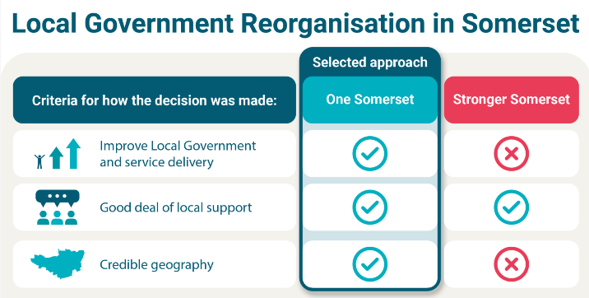

It is expected that the orders will be laid before Parliament in the late Autumn and a vesting date of the new authority as April 2023. Work with partners will now commence to progress through the transition period.

Tick warning: With the warmer weather come ticks, which thrive in woodland, long grass and even urban parks. SCC has put together a ‘tick list’ to follow to reduce the risk of being bitten including: Walking on clearly defined paths, wearing light coloured clothing, using an insect repellent, wearing long trousers and long-sleeved tops to reduce the skin exposure and carrying out a regular tick check after outdoor activities. Being bitten by a tick doesn’t usually require hospital treatment but people are advised to dial NHS 111 if they start to feel unwell.

County-wide Bus Services: Following the Government’s announcement in March of the new National Bus Strategy – ‘Bus Back Better’ a £3 billion pot of funding is being made available to improve bus services across the country and Somerset County Council can bid for a share of this in partnership with operators. But first, the Council needs to know about residents’ experience and where the gaps in services are. You can take the survey at https://somerset.inconsult.uk/somerset.bus.survey/consultationHome

Reflections of the pandemic: The Somerset Library Service is inviting people to share their experiences of the last sixteen months, to be recorded for future generations. As part of ‘Reflections’, a county-wide creative response to the pandemic, libraries will host a series of free drop-in sessions throughout August and online via social media. The collaborative artwork and film will be given to the South West Heritage Trust as a ‘record’ of the experiences of Somerset people during the pandemic. The film and artwork will then be showcased at the evening ‘Reflections’ event to be held on the 10 September. This initiative forms part of Somerset Libraries’ response to initiative, funded by The BBC and Arts Council England.
Summer holidays school meals support: The Department of Work and Pensions has extended its Covid Local Support Grant, providing £1.4m to Somerset County Council who will use the grant to fund food vouchers worth £15 per week for children eligible for Free School Meals over the six-week Summer Holidays. SCC has been working to tackle holiday hunger during the pandemic, providing funding for food and vouchers over the October, February, and May half-term periods, as well as the Christmas and Easter holidays.
Forecast heat wave: Many forecasters are expecting temperatures to rise again in August and so Somerset’s Public Health have issue the following important advice: Look out for others, especially older people, young children and babies and those with underlying health conditions. Stay cool indoors: open windows when the air feels cooler outside than inside; shade or cover windows exposed to direct sunlight; move to a cooler part of the house, especially for sleeping. Keep drinks within easy reach – water is better than sugary or caffeinated drinks for staying hydrated. Avoid excess alcohol. Never leave anyone in a closed, parked vehicle, especially infants, young children or animals. Try to keep out of the sun between 11am to 3pm.
National Recognition: Somerset County Council has been shortlisted for three prestigious national awards in recognition of its work during the coronavirus pandemic. The categories include; ‘Best Workforce Transformation’ for its redeployment work during the pandemic, ‘Community Heroes’ for the work of Community Council for Somerset’s Village and Community Agents, and ‘Delivering Better Outcomes’ for Somerset’s Micro-providers, independent care providers who proved a lifeline for Somerset’s isolated rural population throughout the pandemic.

